

Kids Hope USA

We are looking for the congregations input on the future direction you would like to see Kids Hope USA take. We will be holding a meeting for mentors, prayer partners, sub mentors, party planners and anyone interested in Kids Hope USA. The meeting will be on Tuesday, April 21st at 6:30pm. Your input is very important to us as we make decisions about the future of the program. Please mark your calendars and plan to attend.



We used to love those Easter baskets! But the most wonderful thing about them was the chocolate Easter Bunny, usually wrapped in foil. I always saved that for the last. Jelly beans and peeps were quickly gobbled up. But always to my dismay, when I finally got to nibbling on the chocolate bunny, I was disappointed. Those chocolate bunnies were usually hollow. Every year I waited for a full-fledged, solid chocolate bunny. It was hard to eat a hollow chocolate bunny. Unless I was very careful, at some point it always collapsed into broken bits of chocolate. As an adult I have wondered what chocolate bunnies has to do with Easter.

Our lives are much like those chocolate bunnies. If we are not filled with a good, solid faith, events in life can “crush” us and leave us broken into pieces that can be hard to put back together. Faith and belief in Jesus Christ fills us and helps us stand solidly against the trials and tribulations we face in life.

Easter is the time we can celebrate and reflect on the way that God has brought us the possibility of being solidly who we were meant to be. We can be filled with hope, light, and strength that helps us endure setbacks and rejoice in who we are as followers of the One who teaches us who our creator is and opens our relationship with Him. When we are filled with the light of faith, we can stand solidly in God’s promises and assurances of eternal life. Maybe the question we need to ask of ourselves is whether we are hollow (empty of God’s goodness) or solid (filled with the light and hope we were intended to be filled with)

I am wishing all of us a Happy Easter and may our Easter celebration and season be filling and satisfying.

### Inside This Issue

Rummage Sale 1

Christian Education 2

Fellowship Opportunities 2

Treasurers Report 3

Pastors Resource 3

Mission Minutes 4

Worship Helpers 6

Calendar of Events 7

God’s Dream Seekers News

# Pastors Ponderings

By Pastor Kathleen Groff

###### Newaygo United Methodist Church, P.O. Box 366, Newaygo, MI 49337; email:umcnew@newaygoumc.com; phone: 231-652-6581; website: www.newaygoumc.com

April 2015

Volume 2, Issue 4



& Plant Sale

Memorial Day Weekend

Friday, May 22nd

from 9am – 6pm

Saturday, May 23rd

from 8am – noon

*SPRING CLEANING* – it is time to do your spring cleaning and planting. Please save your household items, furniture, tools, **plants** etc. and donate them to the Church Rummage Sale. NO CLOTHING! PLEASE DONATE YOUR CLOTHING TO LOVE INC.

*This sale is sponsored by the Mary Martha Circle and all monies raised are given to missions that affect women and children, both locally and globally.*

HELP!!!!!!!!!!!!!!!!!!!!!!

* We will need help setting up the tables and items on Thursday, May 21st. We need people who can carry heavy items to help. The sale will be set up upstairs this year.
* People to keep the sale open until 6pm on Friday and to have the sale open on Saturday, 8am-noon (this is also the pancake breakfast).
* People to help clean up and take leftover items to be donated.

*There will be a sign up sheet in the coffee area soon. If we do not get enough helpers, we will have to cancel the sale. Please mark your calendars today and plan to volunteer.*

**

**United Methodist Women’s Meetings**

Each meeting is open to all women. Please join us for which ever one you are able to. You are always welcome.

* **Longcore Circle –**April 7th , at 2pm at Dorothy Sibley’s Home. All are welcome.
* **Ladies Night Out** –Tuesday, April 14th @ 6:30pm – We will have a business meeting and then study a very interesting “Women of the Bible”
* **Mary Martha Circle –** Tuesday, April 21st at 9:30am. All women are welcome.





Men, come join us on **Wednesdays at 8:30am at the City Limits Restaurant**

(next to McDonalds).

It sure is nice to walk in and have coffee ready and poured at the table at the men’s breakfast. Our regular waitress watches and as each member comes in; she knows exactly what we want. Only problem was when she overslept and Vern beat her into work, he had to wait for his coffee!!! Then ordering breakfast is complicated. You see, they have a number for the breakfasts that you might want. Now Ken is pretty steady and hasn’t changed his order in years, he nods and the waitress nods and knows what he wants. Ron says he will take what Ken ordered but isn’t sure what he is getting. Stan takes the special many times and then we come to Vern. He order’s a #2, but then adds this or that so it becomes a #5 or a #3 or a #6 or whatever. Ever wonder why the waitress shakes her head and smiles! So men, fish stories are starting to grow and military stories getting wilder, so stop in and enjoy the friendship on Wednesday at 8:30 at City Limits.

Joe Groff

**Pastor’s Resource List**

We all love our Pastor and would love to keep her as long as possible. One way to do this is to give her all the help we can. We all know that we are an important part of the ministry of the church of Love. The Pastor cannot be expected to do it all. Here is one way we can help: We can become part of a resource team to help our Pastor minister to those in need.

This could include; driving persons to Dr., pick up medicine etc. The church has at times received emergency requests for transportation help. Rather than have the Pastor drop everything and run to drive, we could volunteer to do it.

Another way to help would be to make yourself available to visit those in need of a visit from the church in place of the pastor.

A third possibility would be to take in a food dish to help a family in an emergency.

John Wesley’s philosophy is “DO GOOD”. Here is our chance to do good. We can become part of our **Pastor’s Resource List**. Look for volunteer sign-up sheets at coffee hour on Sunday Mornings.

*Ron Pardonnet*

If you need help with something, please give the church office a call.

We don’t know you need help unless you tell us. Please call

231-652-6581 if you are in need and we will try to find those

within the church that can help.



Ardis Tanis

Dan & Edna Schilling

Nancy Ferguson

Jean Bumstead

Wayne Bumstead

Bill & Freda Corrigan

June Wade

Al Winchel

Marilyn Dawson

Chuck Suess

Peace in the World

*If you have a prayer request or person you would like added to the monthly prayer list, please let Deb Prins know and we will add them to the newsletter each month.*

**Psalm 147:3**  
*He heals the brokenhearted and binds up their wounds.*

*Treasurer’s Report*

Please prayerfully consider how you can help support the ministries of Newaygo United Methodist Church in 2015.

Contributions through

March 25, 2015 - *$ 9029.43*

Expenses through

March 25, 2015 - $9493.31

**Total ($463.67)**

There is still one more Sunday of giving for the month of March. Please remember when looking at the church finances that we have had some pretty cold weather so attendance has been down. When prayerfully considering your giving during the winter months remember the lights and heat are still on even if we can’t make it in.

If you have any questions or would like to see a more detailed report please call Deb Prins at 231-652-6581 or see the copy of the reports posted on bulletin board in the church office.







**Sunday School**

For all ages every Sunday at 11am

***Christian Education Meeting***

***Monday, April 20 @ 6:30pm***

*Note: There will be no Sunday School on Sunday, April 5th. Happy Easter!*

**SCHOLARSHIP FUND**

NUMC will be starting a new scholarship for non-traditional students in our church who are attending or will be attending college or trade school. Right now we have several who are taking college courses.

The scholarship fund has been depleted and we are asking you to prayerfully consider whether you can make a donation to the scholarship fund.

You can make donations by marking them scholarship fund and placing them in the offering plate on Sundays. You may also mail your donations to Newaygo UMC, P.O. Box 366, Newaygo, MI 49337

If you have any questions please contact Kathy Cain at 652-7976.



Centering Prayer & Taize Service

At Saint Marks Episcopal Church

Every Wednesday

March 4th – May 20th

6:00pm – 7:00pm

Come to the silence, slow down the pace, prayer for peace in your hearts, in your community, in the world!!



2015 Pancake

Breakfast

Saturday,

April 25th

Serving 8am-11am

All you can eat pancakes, sausage, scrambled eggs, biscuits & gravy and American fries, drink & fruit.

Mark your calendars today! Invite your friends and neighbors!

**If you can help please see Jean Reynhout ASAP!**



***From the United Methodist Missions:* Supporting the Ministry of Christ Among Native People**

Most Americans today recognize the history following the arrival of the large canoes bore little resemblance to the one all Christians identify as Creator. That’s why the people of the United Methodist Church, Native and non-Native, are creating a new history. Through Native American Ministries Sunday, we’re able to equip and empower Native American Pastors, congregations and seminary students to do what only they can do: authentically worship and serve Jesus.

**Our Giving Allows Native American To Encounter, Worship and Serve Jesus.**

When we support Native American Ministries Day, we equip seminary students who will honor and celebrate Native American culture in their ministries. And we empower congregations that are finding fresh new ways to minister to their communities with the love of Christ.

Our next “noisy offering” will be for the Native American Ministries, please show your love.

***Mission Committee***



# Mission Minutes

“And they found the stone rolled away from the tomb, but when they went in they did not find the body of the Lord Jesus.”  
*Luke 24:2-3*

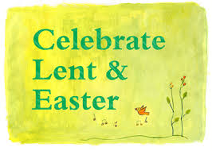

**Sunday, March 29 @ 9:30am**

Palm/Passion Sunday Worship Service

**Thursday, April 2 @ 7:00pm**

Maundy Thursday Worship Service

**Friday, April 3 @ 7:00pm**

Good Friday Worship Service

**Sunday, April 5 @ 9:30am**

*Easter Morning Worship Service*

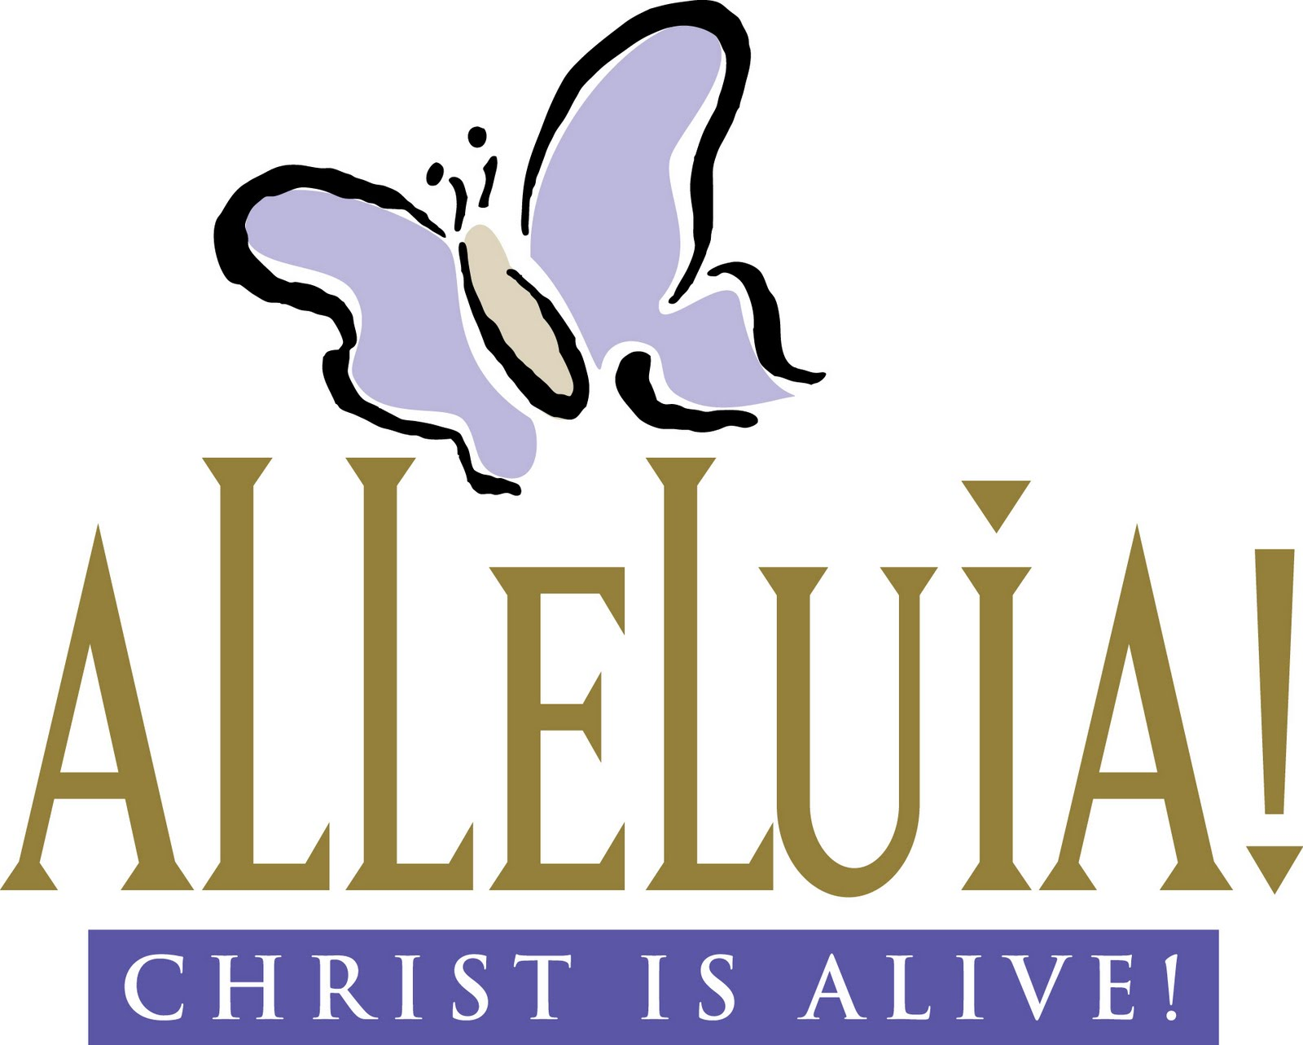







**April 5**  
**Liturgist:**  Joe Groff

**April 26**   
**Liturgist:**  Nancy Clark

**Acolyte:**  Gabriella Brooks  
**Inside Ushers:** Jean Reynhout & Ruth Merritt  
**Outside Ushers:** Janet Fisher & Anne Henning

**Projector:** Elizabeth Brooks

**Sound:** Deb Prins

If you would like to help with worship services on Sunday morning, please see Deb Prins and we will add you to the list of worship helpers.



**Acolyte:**  Saria Brooks  
**Inside Ushers:** Ruth Merritt & Dolores Cook  
**Outside Ushers:** Ron & Kay Pardonnet

**Projector:** Deb Prins

**Sound:** Taylor Prins

**April 12**  
**Liturgist:**  Carline Knoll

**Acolyte:**  Blake Larsen  
**Inside Ushers:** Jane Bode Fowler & Millie Stine   
**Outside Ushers**: Vern & Carolyn Boose

**Projector:** Jen Larsen

**Sound:** Need Volunteer

**April 19**  
**Liturgist:**  Kay Pardonnet

**Acolyte:**  Morgan Pope  
**Inside Ushers:** Jen Larsen & Dianna Weaver

**Outside Ushers:** Carline Knoll & Deb Prins

**Projector:** Taylor Prins

**Sound:** Deb Prins

**April Anniversaries**

4/28 Ray & Missy Webb



**April Birthday’s**

4/3 Debra Prins

4/8 Andy Belew

4/9 David Cain

4/12 Gabriella Brooks

4/13 Cindy Ryan

4/13 Steven Dietz

4/15 Ron Pardonnet

4/22 Dustin Prins

4/29 Trevor Cutler

4/30 Julie Cain



|  |  |  |  |  |  |  |
| --- | --- | --- | --- | --- | --- | --- |
|  |  |  |  |  |  |  |
| **Sunday** | **Monday** | **Tuesday** | **Wednesday** | **Thursday** | **Friday** | **Saturday** |
|  |  |  | 1  8:30am – Men’s Group @ City Limits  9am -12pm Pastor Kathy’s Office Hours  7pm – Choir Practice | 2  Pastor Kathy’s Day Off  7pm – Maundy Thursday Worship Service | 3  7pm – Good Friday Worship Service | 4 |
| **5 EASTER SUNDAY**  9:30am – Worship  11am – Sunday School for all ages | 6  9am -12pm Pastor Kathy’s Office Hours  1:00pm – Wired Word Bible Study | 7  2:00pm – Longcore Circle | 8  8:30am – Men’s Group @ City Limits  9am -12pm Pastor Kathy’s Office Hours  7pm – Choir Practice | 9  Pastor Kathy’s Day Off | 10 | 11 |
| **12**  9:30am – Worship  11am – Sunday School for all ages | 13  9am -12pm Pastor Kathy’s Office Hours  1:00pm – Wired Word Bible Study | 14  6:30 –Ladies Night Out – UMW MEETING – Planning Worship on April 26th & May Tea & Rummage Sale | 15  8:30am – Men’s Group @ City Limits  9am -12pm Pastor Kathy’s Office Hours  7pm – Choir Practice | 16  Pastor Kathy’s Day Off | 17 | 18 |
| **19**  9:30am – Worship 11am – Sunday School for all ages | 20  9am -12pm Pastor Kathy’s Office Hours  1:00pm – Wired Word Bible Study  6:30pm – Christian Education Mtg. | 21  6:30pm – Kids Hope USA Meeting | 22  8:30am – Men’s Group @ City Limits  9am -12pm Pastor Kathy’s Office Hours  7pm – Choir Practice | 23  Pastor Kathy @ Texas | 24  Pastor Kathy @ Texas | 25  4th Saturday Pancake Breakfast  Pastor Kathy @ Texas |
| **26 NOISY OFFERING**  9:30am – Worship – UMW Celebration Service  11am – Sunday School for all ages  Pastor Kathy @ Texas | **27**  Pastor Kathy @ Texas  1:00pm – Wired Word Bible Study | **28** | 29  8:30am – Men’s Group @ City Limits  9am -12pm Pastor Kathy’s Office Hours  7pm – Choir Practice | 30 |  |  |

Newaygo United Methodist Church Activities –2015



*We’re on the Web!*

*Visit us at:*

[www.newaygoumc.com](http://www.newaygoumc.com)

or check us out on facebook: Newaygo United Methodist Church

We are God’s Dream Seekers who seek to make disciples of Jesus Christ in ways that show love, respect and service to our community.

Mission

Newaygo United Methodist Church

P.O. Box 366

Newaygo, MI 49337

Join us on Sunday Mornings for Worship at 9:30am with fellowship following. Sunday School for all ages at 11am.

If you have any questions or would like more information regarding worship services and activities at Newaygo United Methodist Church please feel free to call the church office Monday-Thursday 9am-1pm.

##### Newaygo United Methodist Church

P.O. Box 366

Newaygo, MI 49337

##### Phone:

231-652-6581

##### Fax:

231-652-6601

##### E-Mail:

umcnew@newaygoumc.com